**CERTIFICATE**

Certified that this Micro-Project Report

**“Nursery Plants Management System”**

Is the work of

|  |  |  |
| --- | --- | --- |
| **Roll No.** | **Enrollment No.** | **Student Name** |
| 10 | 1900150416 | Dhumal Aniket Harishchandra |
|  |  |  |

The student of Semester four Subject Name-GUI Application Development Using Vb.Net (22034) Diploma in Information Technology , 2020-21.

This report is a partial fulfilment of subject GAD(22034) for the award of the Diploma in Information Technology , By MSBTE, Mumbai.

**Guide Name – Prof. Kurapati Mam**

**Date & Sign -**

**HOD PRINCIPAL**

**CERTIFICATE**

**MAHARASHTRA STATE BOARD OF TECHNICAL EDUCATION MUMBAI**

**GOVERNMENT POLYTECHNIC, SOLAPUR**

This is certify **Ms. Dhumal Aniket Harishchandra Roll No:10 of** Fourth Semester of Diploma in Information Technology of Institute **Government Polytechnic, Solapur (Code:** **0015)** have complete the micro-project work satisfactorily under my supervision and guidance in subject **GUI Application Development using VB.Net(22034)** for the academic year **2021-2022** as prescribed in the curriculum.

(Project Guide) H.O.D Principal

**Prof. Kurapati Mam** Mr. R.B. Mahajan

**CERTIFICATE**

**MAHARASHTRA STATE BOARD OF TECHNICAL EDUCATION MUMBAI**

**GOVERNMENT POLYTECHNIC, SOLAPUR**

This is certify **Ms.­­­­­­­­­________________________________ Roll No:__+ of** Fourth Semester of Diploma in Information Technology of Institute **Government Polytechnic, Solapur (Code:** **0015)** have complete the micro-project work satisfactorily under my supervision and guidance in subject **GUI Application Development using VB.Net(22034)** for the academic year **2021-2022** as prescribed in the curriculum.

(Project Guide) H.O.D Principal **Prof.Kurapati Mam** Mr. R.B. Mahajan

**Nursery Plants Management System**

**GOVERNMENT POLYTECHNIC, SOLAPUR**

**MAHARASHTRA STATE OF TECHNICAL EDUCATION, MUMBAI**

**A PROJECT REPORT**

Submitted by:

**Dhumal Aniket Harishchandra**

**Roll No:-10(IF4I)**

**Enrollment No: 1900150416**

IN PARTIAL FULFILLMENT OF THE FOURTH SEMESTER

**ACKNOWLEDGMENT**

**We wish to express our profound and sincere gratitude to our guide.**

**Who guided us into the intricacies of this micro-project non-chalantly with matchless magnanimity. We are indebted to his constant encouragement, co-operation and help. It was his enthusiastic support that helped us in overcoming him various obstacles in this project.**

**We would also like to express our thankfulness to our beloved Principal, H.O.D., and other faculty members our Second Year Department for extending their support and motivation.**

**Thank You…..!!!!**

**PART A – Micro-Project Proposal**

**Title of Micro-Project: Nursary Plants Management System**

1. **Brief Introduction**

Nursery is a place where planting material, such as seedlings, saplings, cuttings, etc., are raised, propagated and multiplied under favourable conditions for transplanting in prepared beds. The availability of quality and true-to-type planting material is the prerequisite of successful and remunerative ornamental crop production. Setting up of a nursery is a long-term venture, and requires planning and expertise. In a nursery, plants are nurtured by providing them with optimum growing conditions to ensure germination. Nursery saves considerable time for the raising of the next crop. Among flower crops, majority of the annuals are propagated by seeds and require a nursery for raising the seedlings. Herbaceous perennials need nurseries for sowing of seeds and planting of cuttings for rooting and establishment. Woody perennials are grown from seeds for multiplying the rootstocks from cuttings, layers and through grafts to perpetuate the same genetic properties.

**2.0 Aim of the Micro-Project** (in about 1 to 2 Sentences)

**This Micro-Project aims at:**

1. Demand for planting material, provision of mother blocks, requirement of land area, water supply, working tools, growing structures and input availability.
2. land treatment, protection against biotic interference and soil erosion, proper layout, input supply, etc..
3. **Intended Course Outcomes**

* Use Visual Studio IDE to design the application.
* Develop GUI Application using Form Windows and its events.
* Apply Object Oriented Concepts in GUI Application.
* Use data access control to store data in Database and Retrieve it.
* Use Data Binding in GUI Application

1. **Literature Review**

For this micro project we took help of teachers and internet. We run the project program on notepad. And collected the information from various .Net books and many website.

**5.0 Proposed Methodology**

* We Made the coding carefully in visual studio 2019 by using Windows Forms app(.net framework).
* Then save the coding and then compile the coding.
* In compile time some error are shown in my programme.
* Then Remove the error in the programme.
* And save the programme and again compile the programme and programme compile successfully.
* Then run the programme and see the output of programme and mention the output of given programme.

**6.0 Resources Required** (major resources like raw material, tools, software etc.)

|  |  |  |  |
| --- | --- | --- | --- |
| **Sr. No.** | **Name of Resource/material** | **Specifications** | **Qty** |
|  | Computer systems | Core i5,8GB RAM , 1TB HDD | 1 |
|  | Software(Visual Studio 2019) | 8GB RAM ,64 bit | 1 |
|  | MS Word Office | 64 bit | 1 |

**7.0 Action Plan** (Sequence and time required for major activities for 8 Weeks)

|  |  |  |  |  |
| --- | --- | --- | --- | --- |
| **S. No.** | **Details of activity** | **Planned Start date** | **Planned Finish date** | **Name of Responsible Team Members** |
|  | **To decide the topic of the project**. | 30-05-2021 | 30-05-2021 | All |
|  | **Collect all resources to creating project.** | 31-05-2021 | 31-05-2021 | All |
|  | **Take guidance from teachers. And perform the coding then** | 01-06-2021 | 02-06-2021 | All |
|  | **Preparing and presenting the project.** | 04-06-2021 | 05-06-2021 | All |

**\*\*\*\*\*\*\*\*\*\*\*\*\*\***

**PART B – Micro-Project Report**

**Title of Micro-Project: Nursery Plants Management System**

**1.0 Rationale**

Vb.Net is the programming language based on Object Oriented Concept which is prominently used to develop GUI based Application. Graphical

(GUI) based application includes various user friendly controls to accept or display data This Course Will give the student an in the depth understanding of the concept used in VB.NET and necessary skills to use programming technics to develop .NET based application and display the same.

**2.0 Course Outcomes Addressed**

* Use Visual Studio IDE to design the application.
* Develop GUI Application using Form Windows and its events.
* Apply Object Oriented Concepts in GUI Application.
* Use data access control to store data in Database and Retrieve it.
* Use Data Binding in GUI Application

**3.0 Literature Review**

For this micro project we took help of teachers and internet. We run the project program on notepad. And collected the information from various .Net books and many website.

**4.0 Actual Methodology Followed**

1. To search the topics and collect the information related project.

2. To learn the syllabus about project.

3. To conversation between teachers and friends.

4. To create a word document of project.

5. To preparation and presenting the project.

**5.0 Actual Resources Used (**Mention the actual resources used)**.**

|  |  |  |  |
| --- | --- | --- | --- |
| **S. No.** | **Name of Resource/material** | **Specifications** | **Qty** |
|  | Computer system | 4 GB RAM,64 storage | 1 |
|  | Android | 4 GB RAM,64 storage | 1 |
|  | Laptop | 4 GB RAM,64 storage | 1 |

**6.0 Skill Developed / learning out of this Micro-Project**

* Communication skill.
* Presentation skill is developed.
* How to make a project. This skill is learnt throughout the micro project.
* Technical knowledge is developed.

1. **Applications of this Micro-Project**

* Slow growing species needs a nursery to be planting out to avoid competition.
* The best method of introduction of exotics is only by nursery.
* Casualty replacement is only possible by the plants grow in the nursery.

**8.0 Area of Future Improvement**

             Some ideas and features can be considered as a future work for this project. These features can

Be summarized in the following points:

* We will add extra features in this project like Plant images ,information about natural fertilizer .

**\*\*\*\*\*\*\*\*\*\*\*\*\*\***

**Coding**

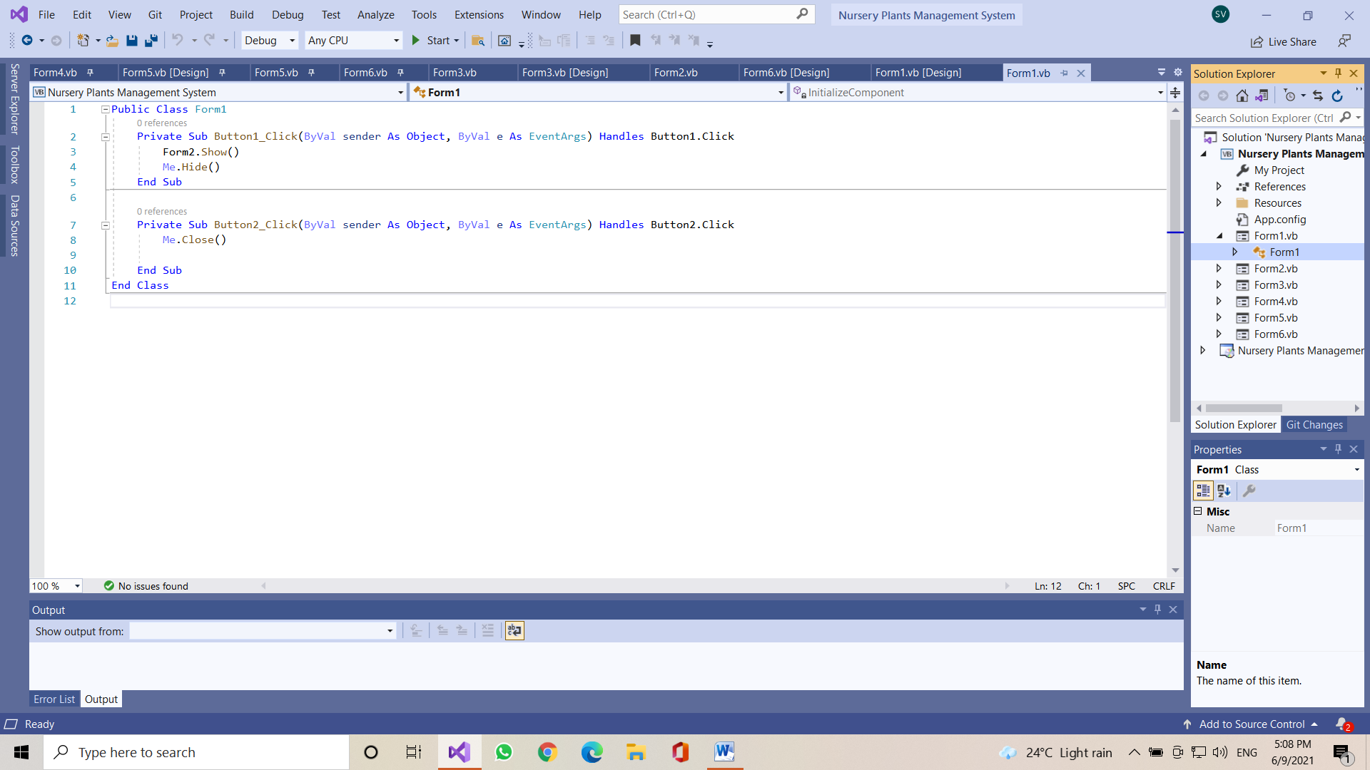

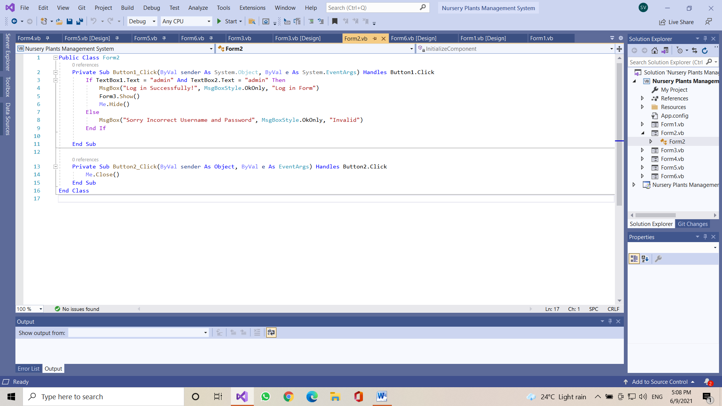

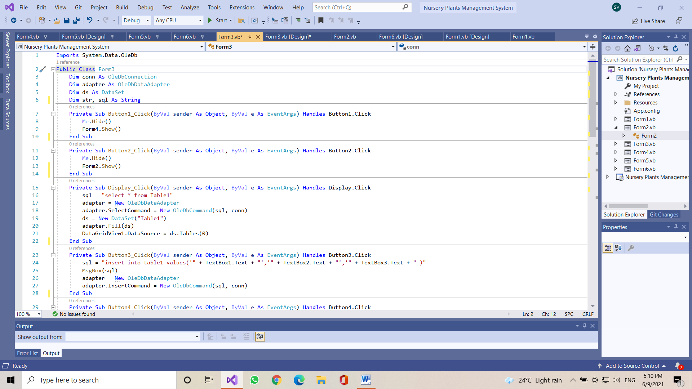

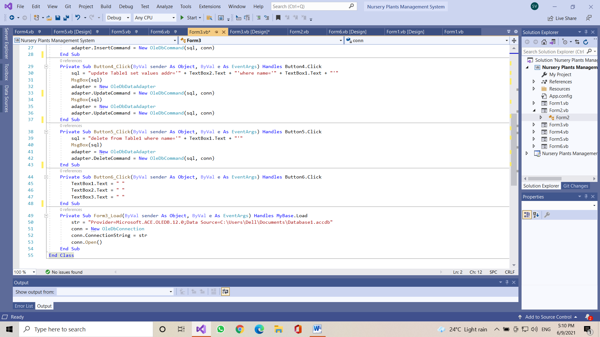

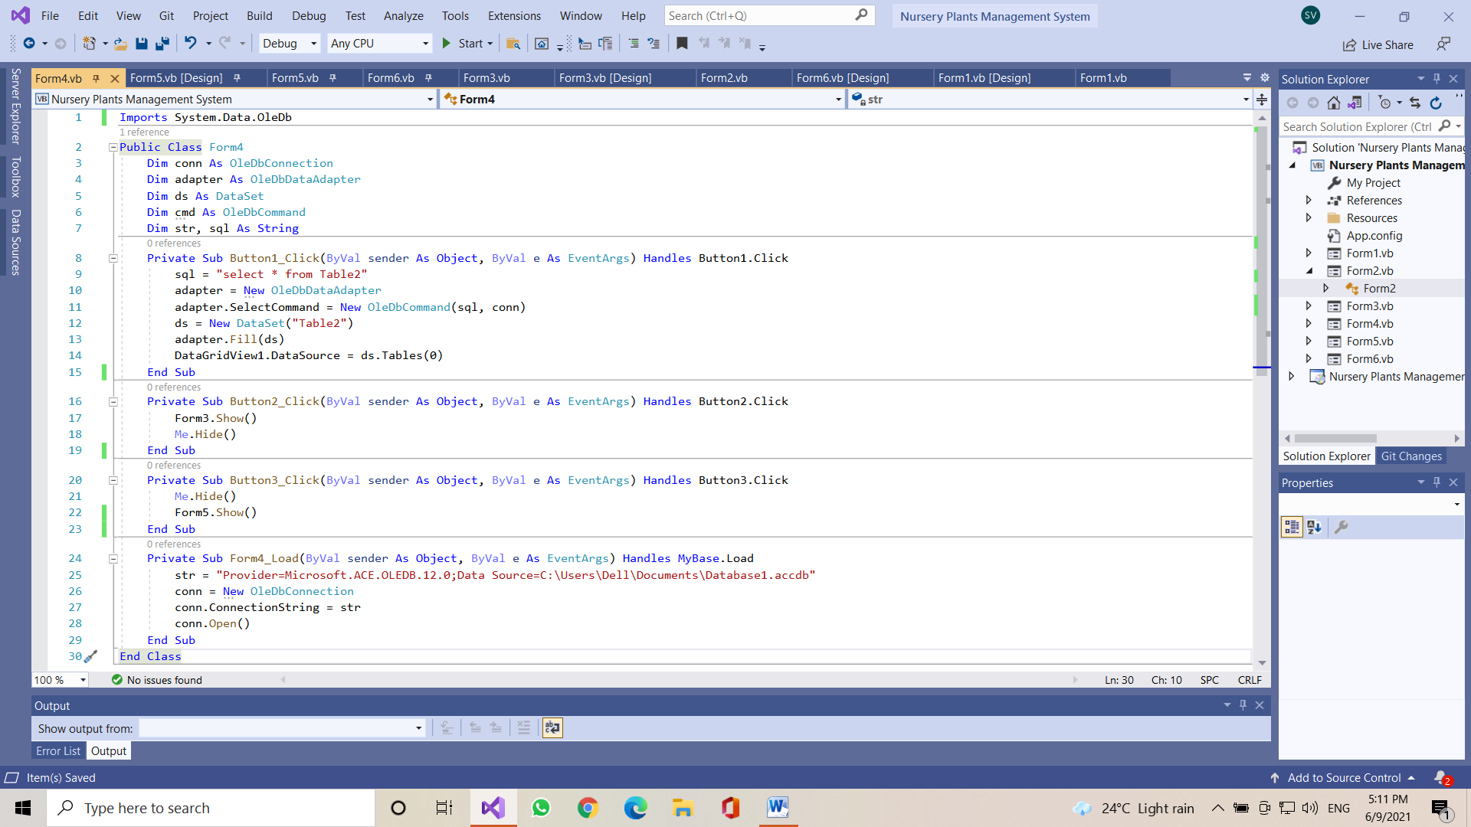

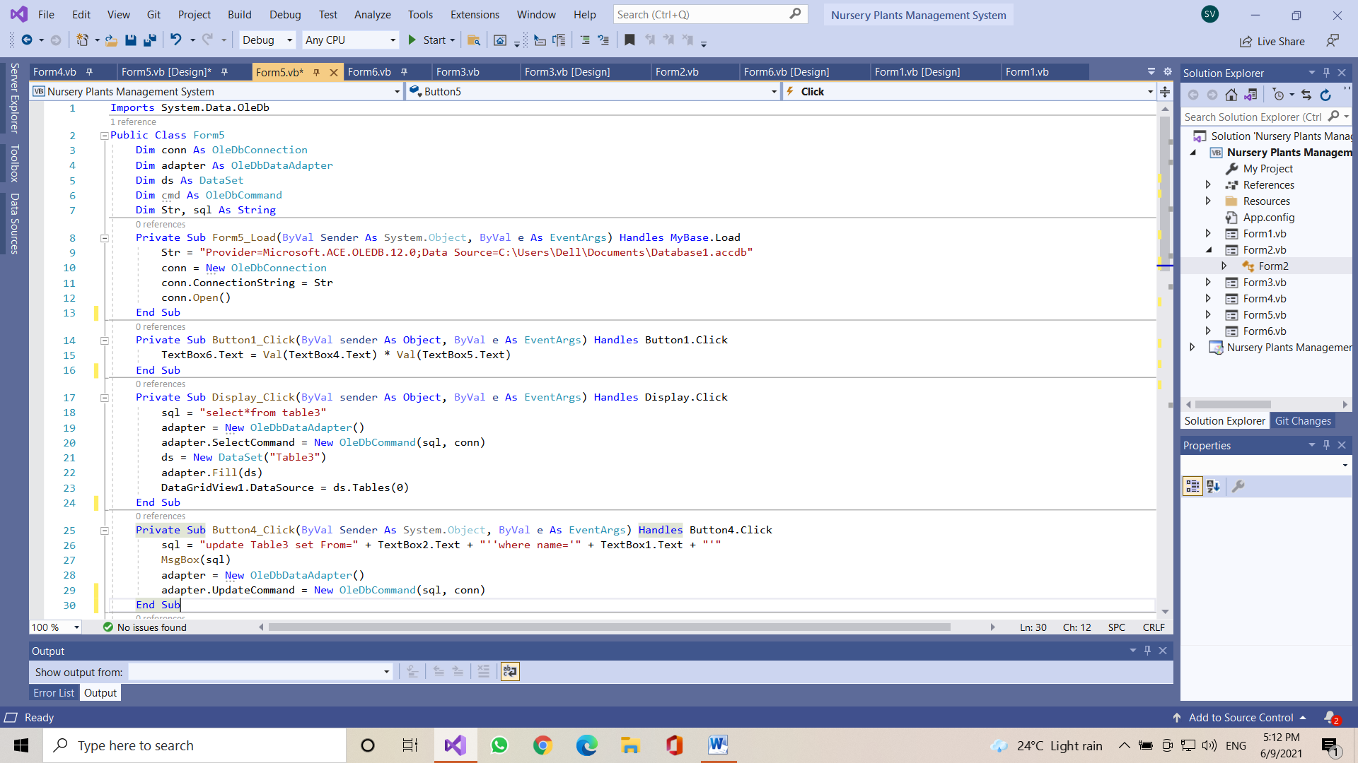

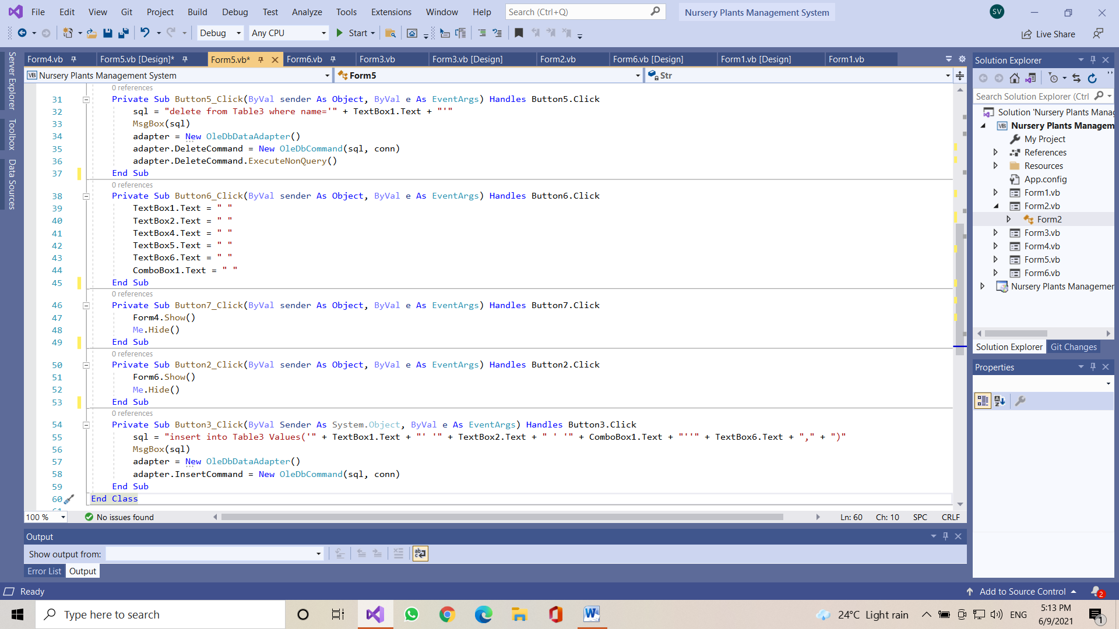

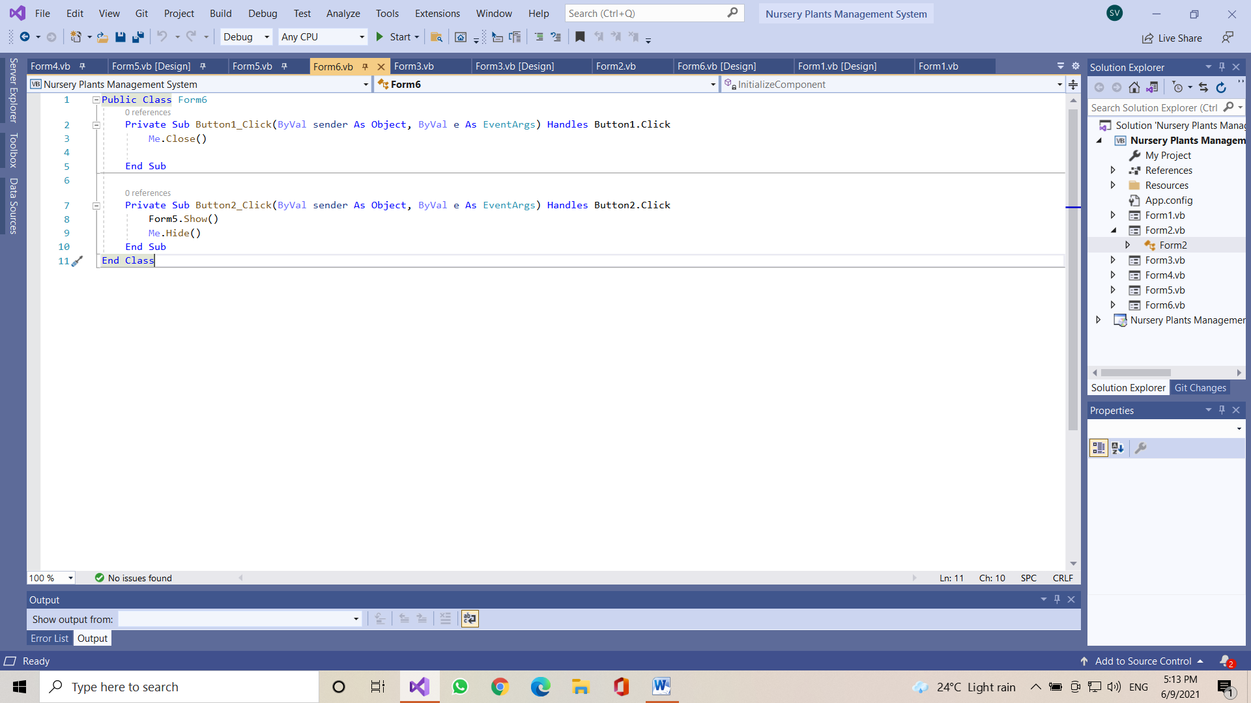

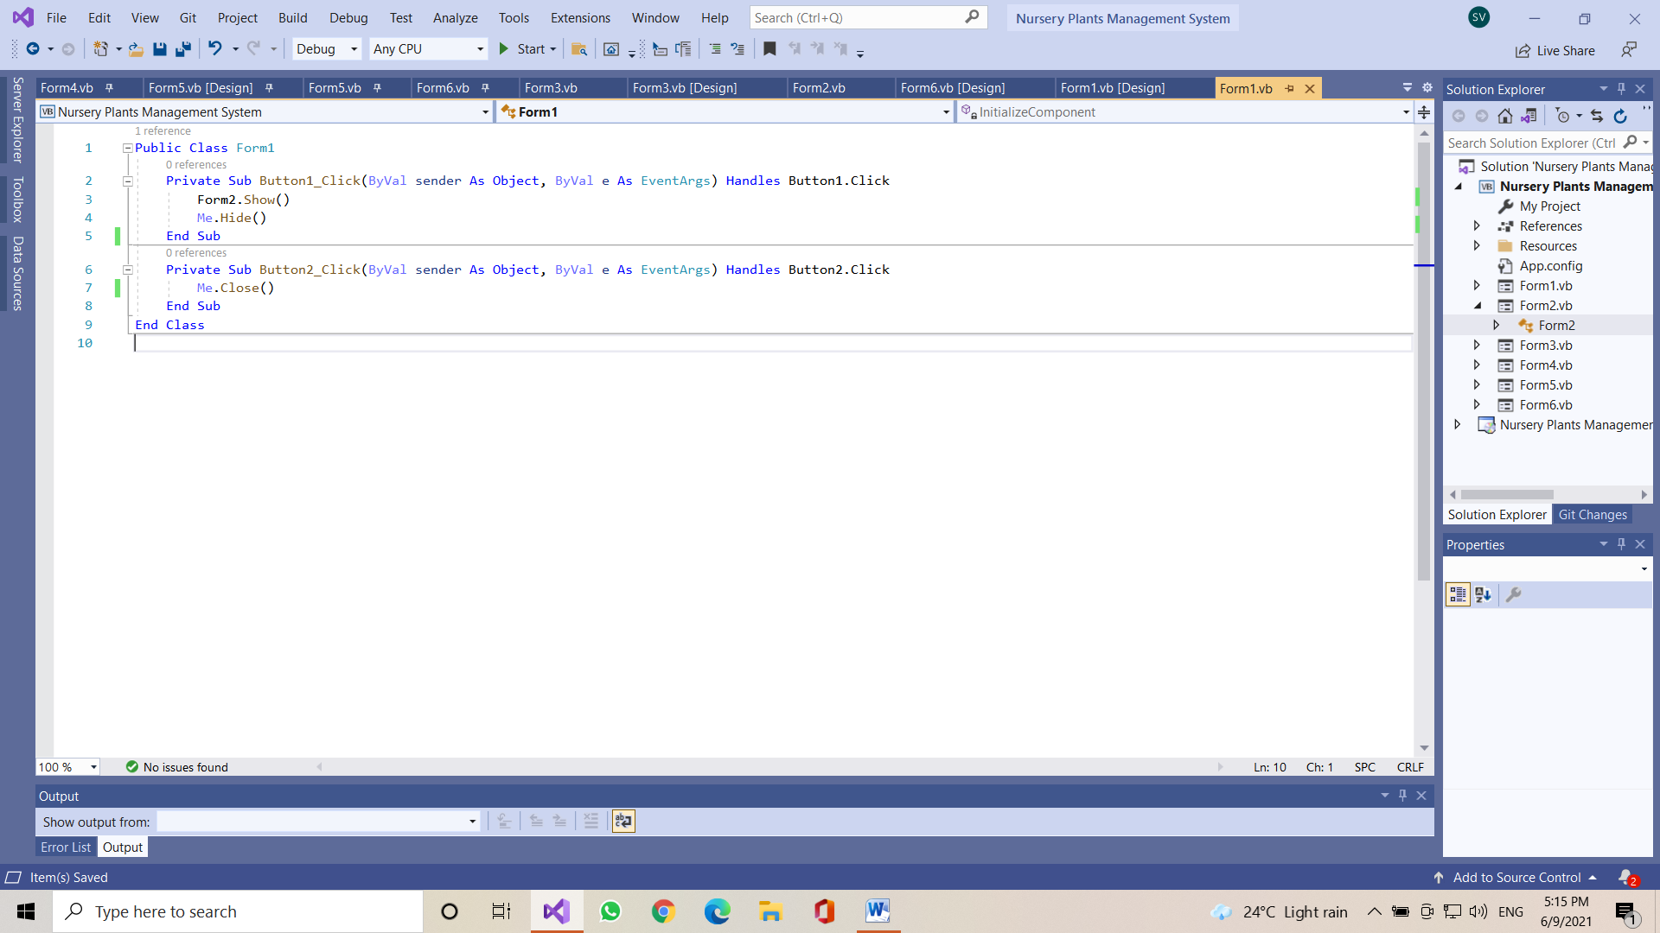

**Output**

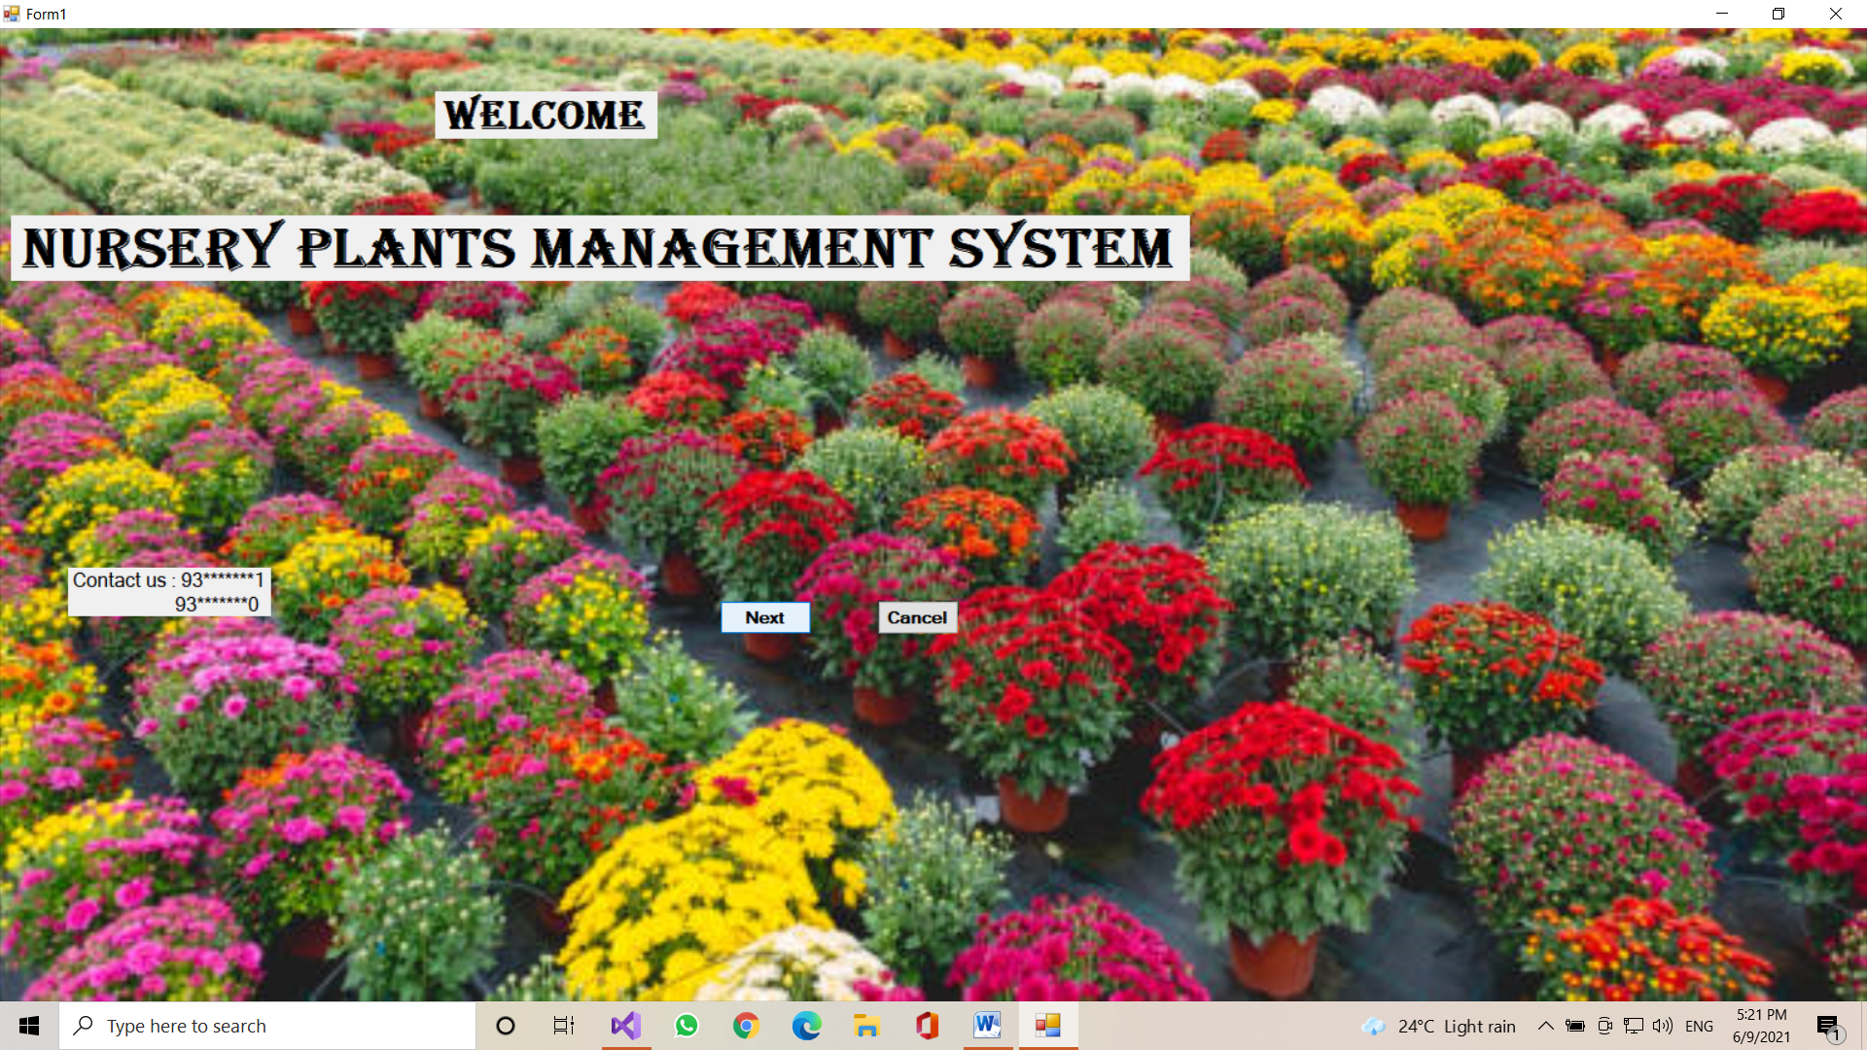

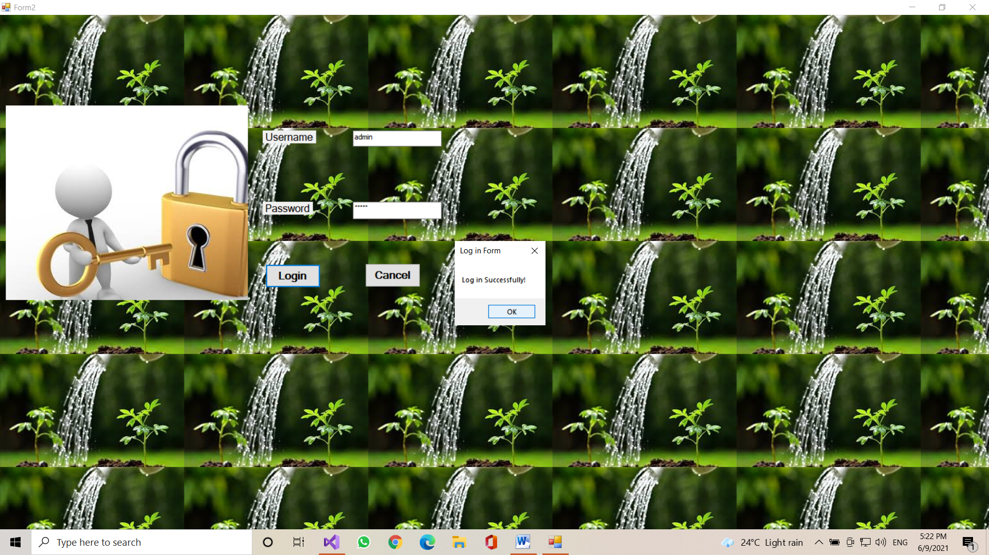

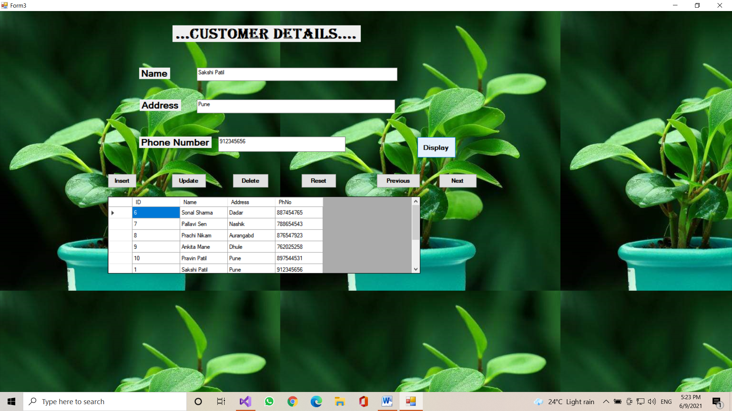

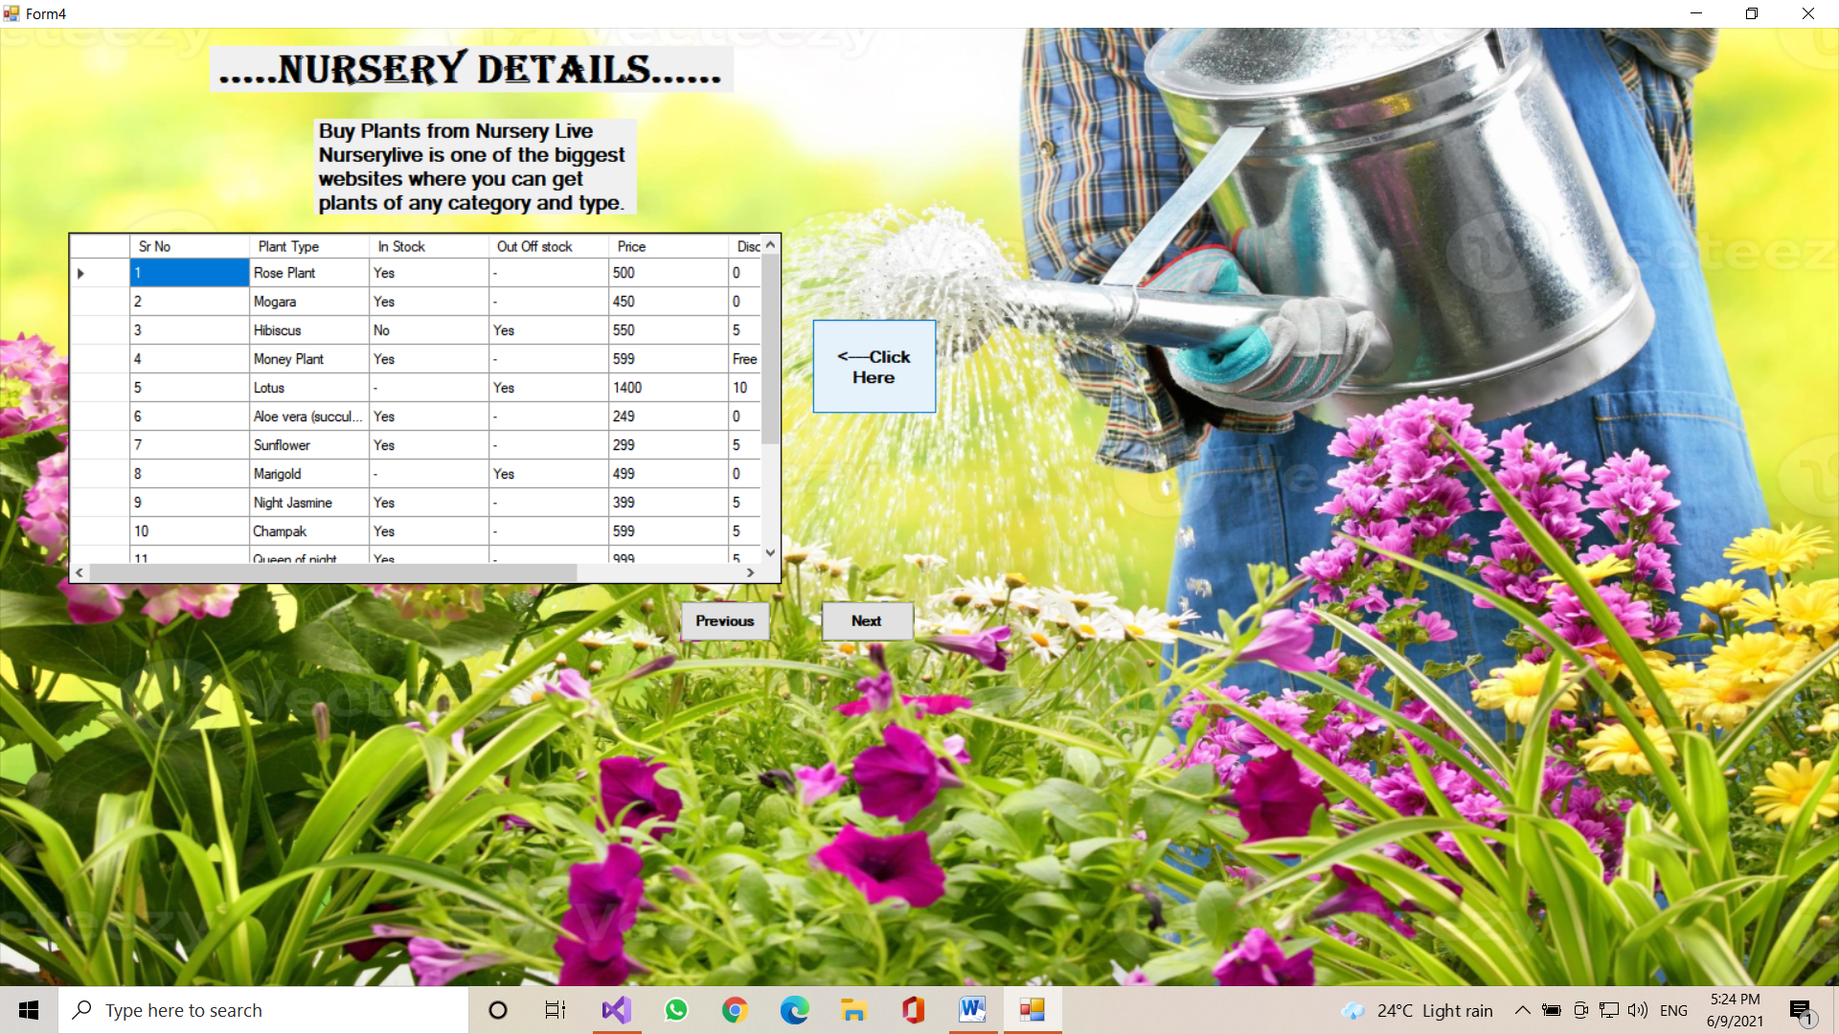

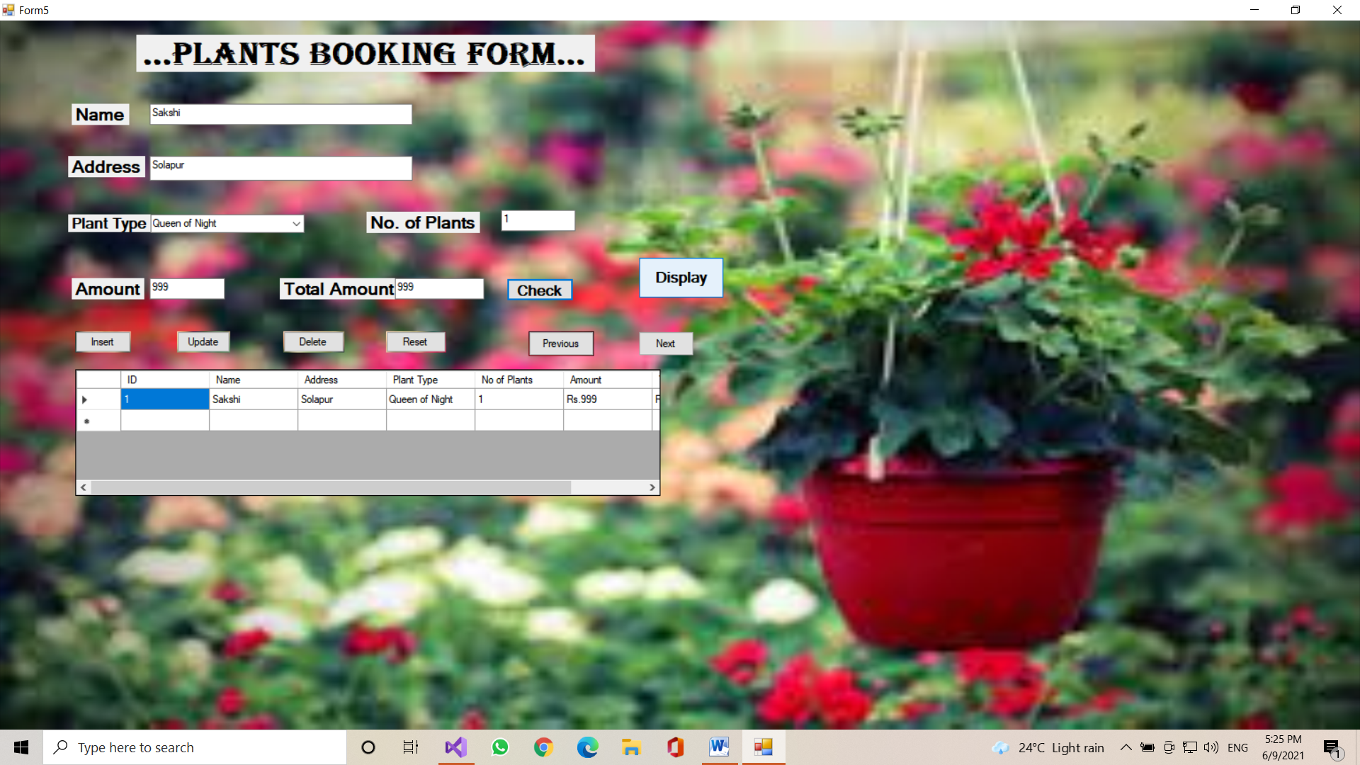

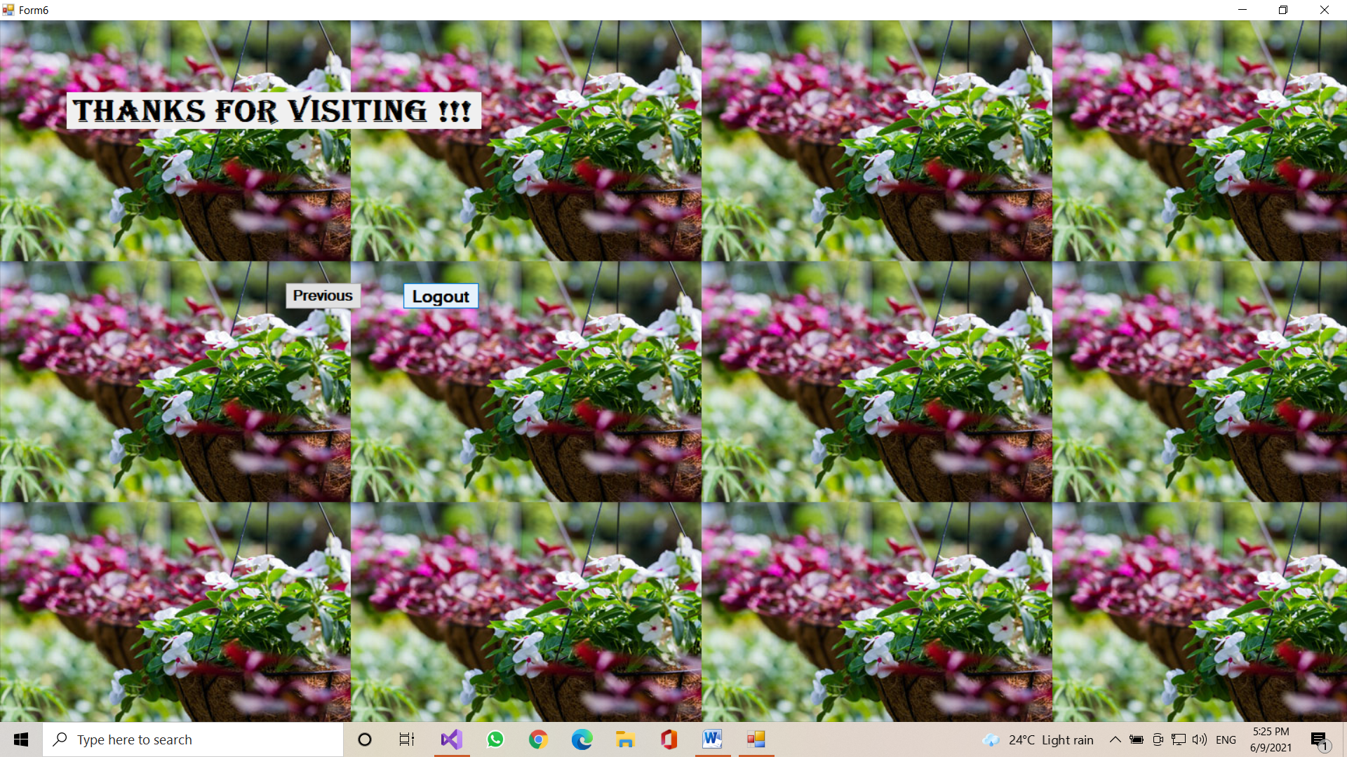

**Conclusion**

From this micro-project we can learn how to implement the program of nursery plant management system, implement Setup file, etc.